GOOD EARTH PLANT CO. INC

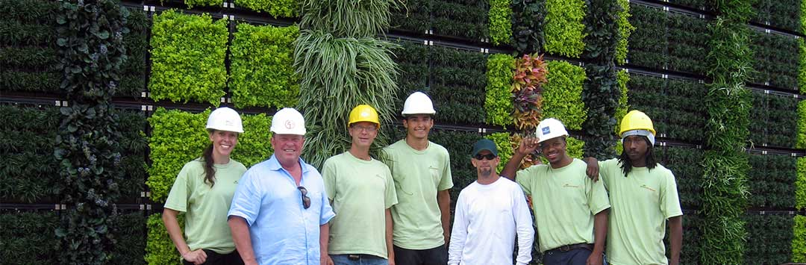



Headquartered in San Diego, Good Earth Plant Company and GreenScaped Buildings lead the way in improving the quality of life in the home and workplace environment by bringing people and plants together.

### Good Earth Plant Company, Inc.

7922 Armour Street  
San Diego, CA 92111

[www.goodearthplants.com](http://www.goodearthplants.com)

**Send Resume to:**

[**alexa@goodearthplants.com**](mailto:alexa@goodearthplants.com)

We are an equal opportunity employer and do not discriminate on the basis of race, religion, color, sex or sexual preferences, age, national origin or disability

**Design/Sales**

**Horticultural Technicians**

**Installations**

**Administration**

Whether you are looking for a job in **Operations** or interested in getting out in the field as a **Sales & Design** Consultant, **Installer**, or **Service Technician**, we would like to offer you the opportunity to talk with us about your future in the green industry.

Our business is **plantscaping**.

We look for open-minded, energetic, honest people who work well both individually and as a team player.

.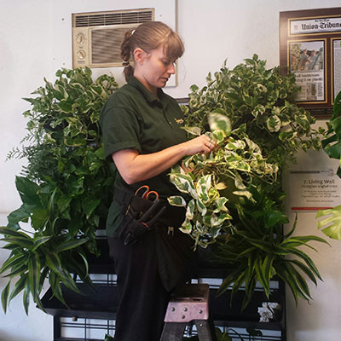 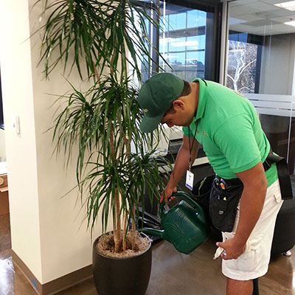 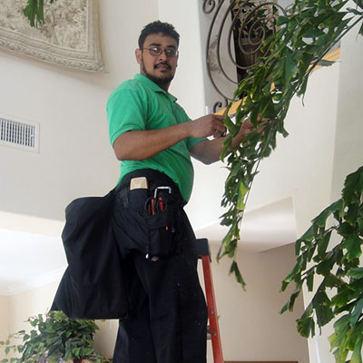

## NOW HIRING!