The Good Earth Family of Companies

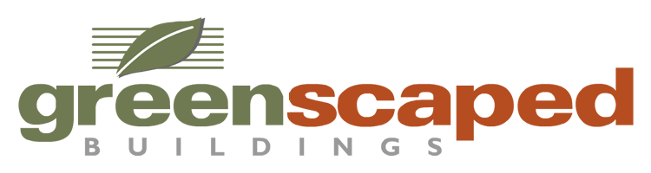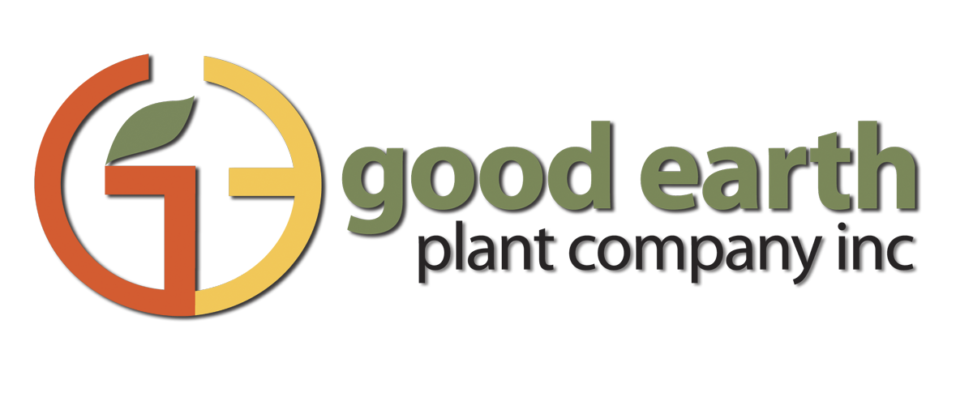

**Internship Program: Human Resources**

**Job Description:**

The HR Intern provides quality HR compliance and administrative support to the HR Team clients and teammates. Interns are responsible for delivering assistance and administrative support to HR generalists and consultants on various projects.

**Responsibilities:**

* Create employee survey
* Develop and Maintain HR Compliance Knowledge
* Begins to develop a current knowledge of HR Laws and Regulations.
* Pursue an Attitude of Learning and Development
* Cultivate interpersonal skills
* Foster time management skills
* Track progress, deadlines, and priorities of all projects
* Prepare Word, Excel and PowerPoint documents
* Proofread HR documents including audits, marketing information, and handbooks.
* May be responsible for making meeting and travel arrangements
* Ensure Career Builder and Monster job packs are current with available job ads
* Update Employment Processes
* Track cost and effectiveness of media outlets for job postings
* Post new positions on various websites including Monster.com, Career
* Builder.com, and Indeed.com
* Sort incoming resumes and logs them into appropriate tracking spreadsheets
* Complete and mail out regret letters
* Coordinate candidate interviews
* Send background checks to Active Screening and save results when they are returned
* Complete and mail out offer letters
* Work proactively with other team members.
* Prioritize activities for the best interest of the team when working on joint projects.
* Openly share new ideas and information with other team members.

**Requirements:**

Good Earth Plants and GreenScaped Buildings is looking for an undergraduate student in the San Diego area who is majoring in Human Resources. This person should have excellent verbal and written communication skills, with the ability to effectively learn and acquire new knowledge and skills. Must be proficient in PowerPoint, Word and Excel.

**This is an un-paid internship with flexible hours.**